# Testing

## User testing

#### Devices

The family and kids were encouraged to test the live site on their devices. They found quite a few bugs which had to be fixed. Thanks kids!

|  |  |  |  |  |
| --- | --- | --- | --- | --- |
| **Device type** | **Model Name** | **Software Version** | **Landscape** | **Portrait** |
| **Phone** | iPhone7 | 14.2 |  |  |
|  | iPhone 8 |  |  |  |
|  | iPhone 5s |  |  |  |
| **MAC Book PRO** |  |  |  |  |
| **iPAD** |  |  |  |  |
| **PC** |  |  |  |  |

### Zoom testing

We tested the site on various browsers on the devices above. We used the zoom option on all devices to check that the site was responsive and adaptive!

### Landscape/Portrait testing

When turning an iPhone for example, the code adapted to the orientation.

### Accessibility testing

Form role=”form” allows someone with a screen reader to jump directly to the form by using the keyboard. It’s important for accessibility purposes.

Used labels for inputs – making it easier for someone with a disability to navigate through the form. Labeled and linked up with ID.

### Test Plan

Website testing was performed on the deployed site. It included testing of the following:

* Outgoing links
* Internal links
* Anchor links
* MailTo links
* Testing of forms – confirm default values work. Confirm submit works.
* Testing of the cookies – to check that 2 places where cookies are used.
* There were a number of issues to clear up with outgoing links – we had to go back and change the teamK website to “#” as we had no operating website to link to.
* The following shows the mailto testing:
* 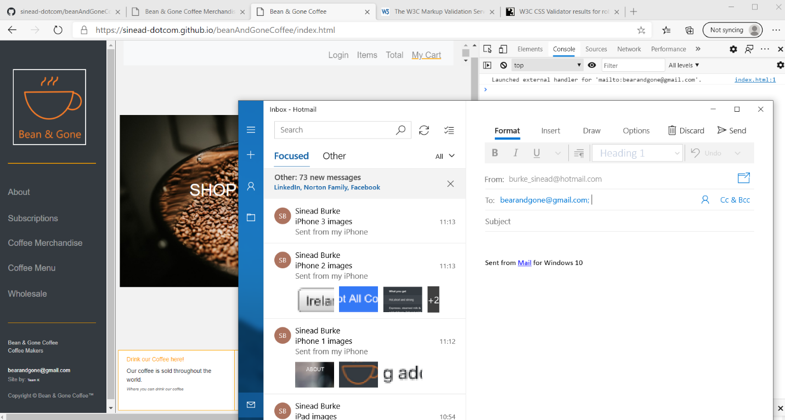
* There are 2 places on each page where this can be called. Tested all.

### Test Results

### Feedback from Test Results

## Functional testing

Besides the basic testing of all functionality on each page we tested external links.

Tested links to Twitter:

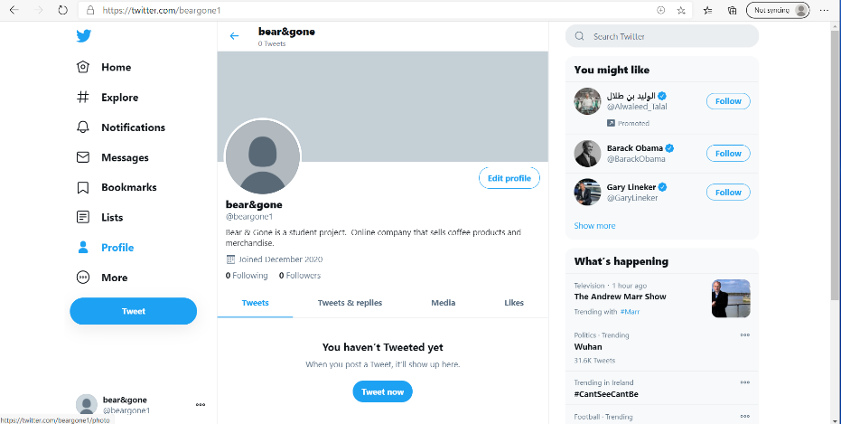

And tested the link to Facebook:

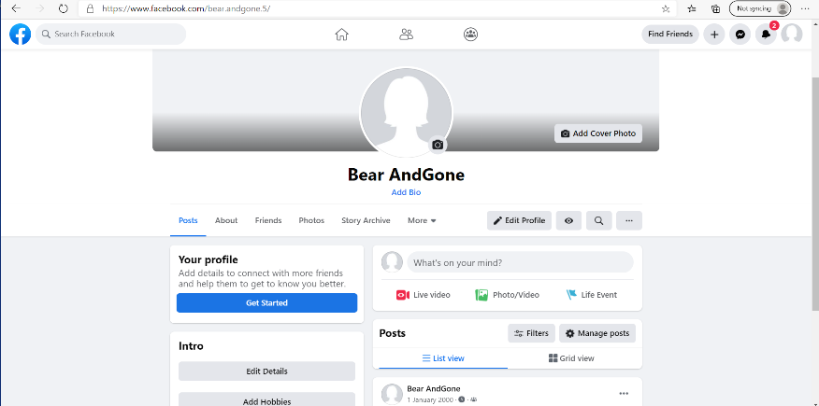

## Functional Cookie Testing

Testing of Cookies:

* The previous days cookies had disappeared – would like to retest this again as only did this test once
* On a browser with a LIVE site we tested the cookies. Starting from zero cookies.
* 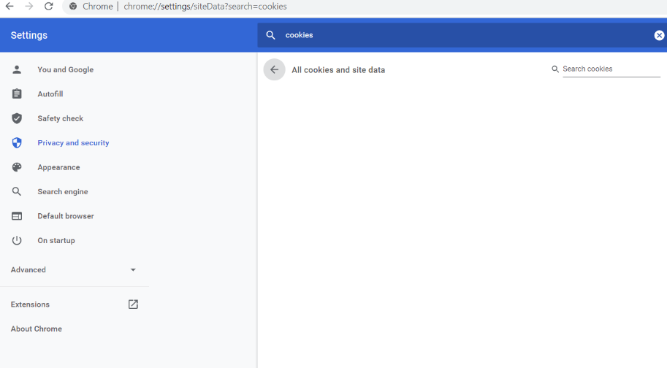

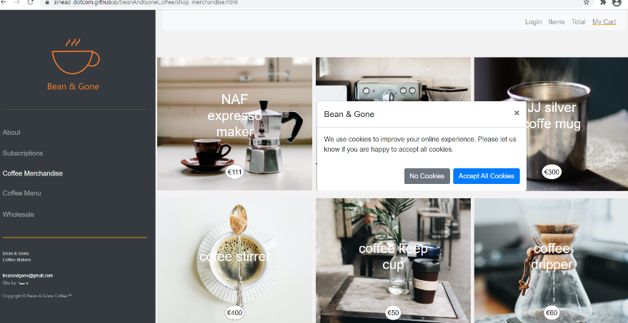

Firstly, we accept all cookies in this modal popup. We see that the cookie is seen and stored.

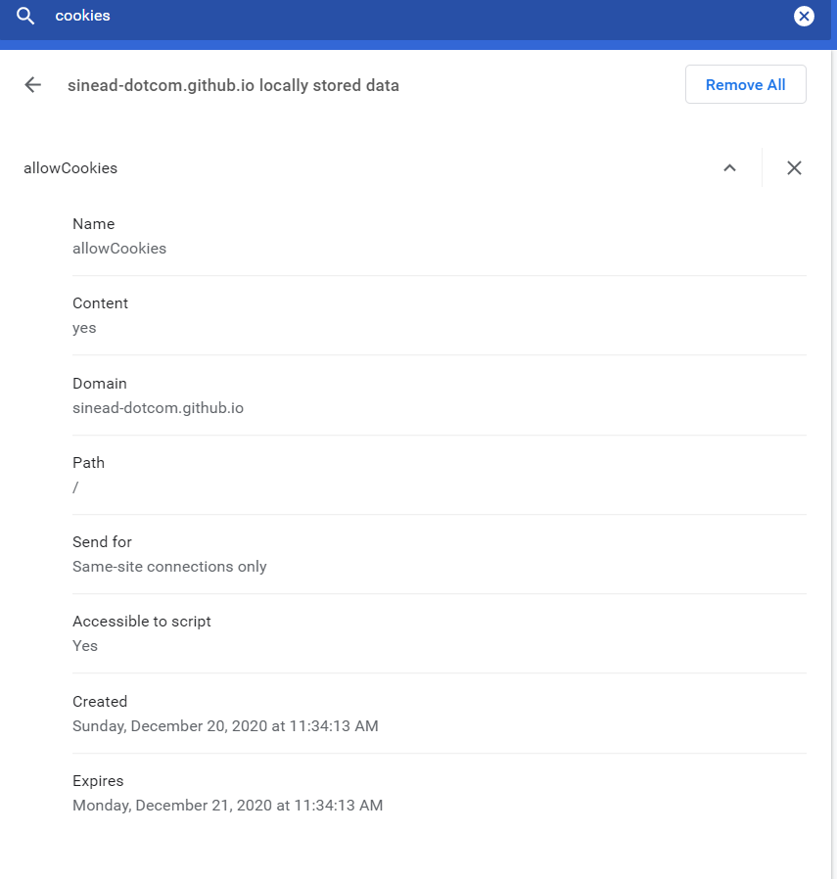

And the details of the cookie are: 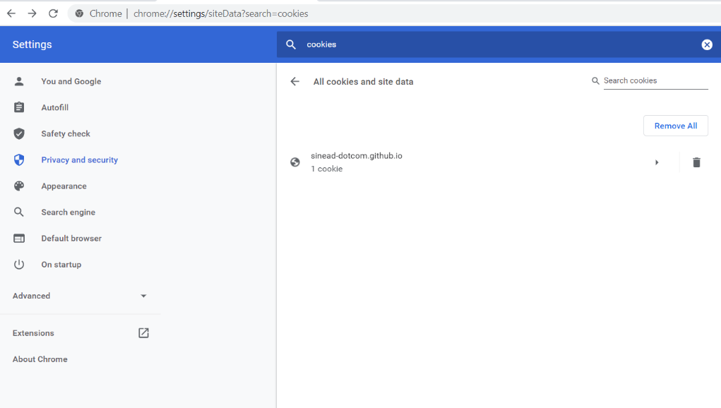

As you can see this is to identify that the user has agreed for cookies to be used/stored. Also, the expiry date is set correctly.

Next we choose a product, a cookie is used to store this chosen product. This means that when it clicks through to the product page that it knows which one to load.

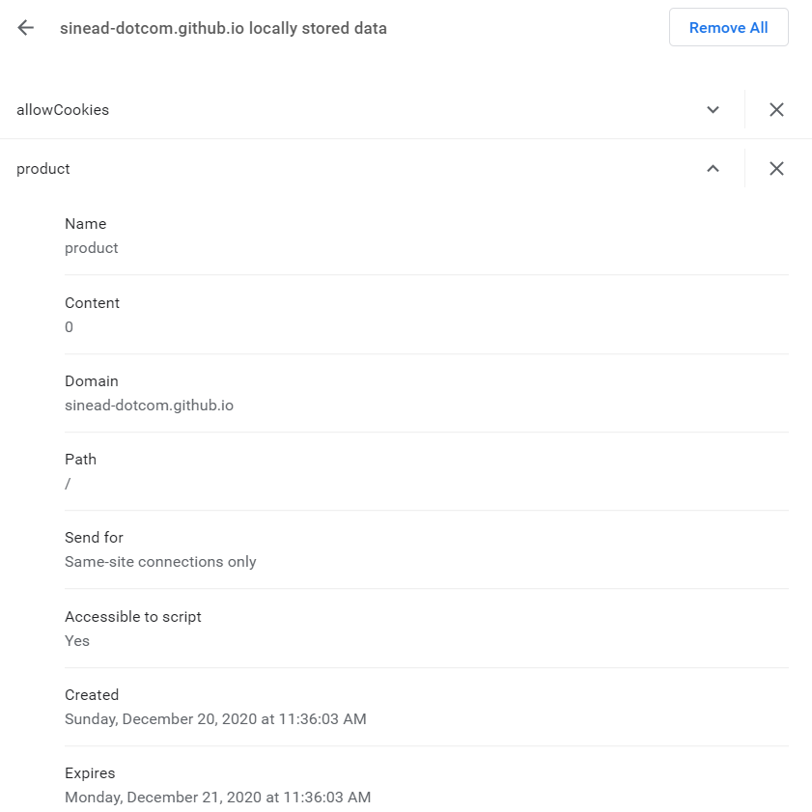

And, it also is stored for 1 day only.

Now that we have the correct product loaded. Lets add this product to the cart. Again a cookie is successfully stored to record this. This will help when I get the basket working.

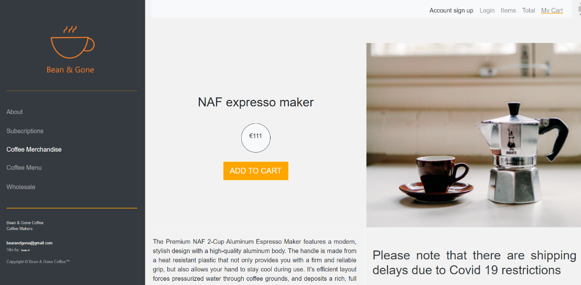

We now have 3 cookies.

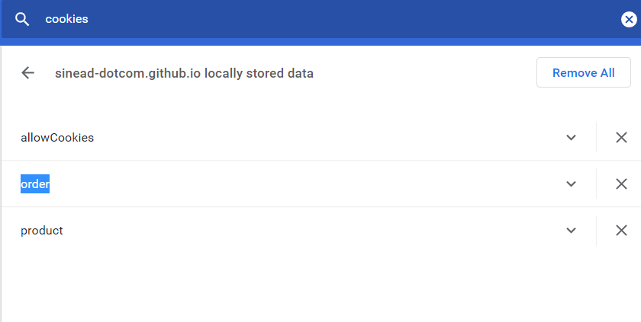

And this is the order cookie details – correctly set! Again this happened when the checkout button was clicked. I would like to show the addition of this item to the basket on the top NAV bar if there is enough time.

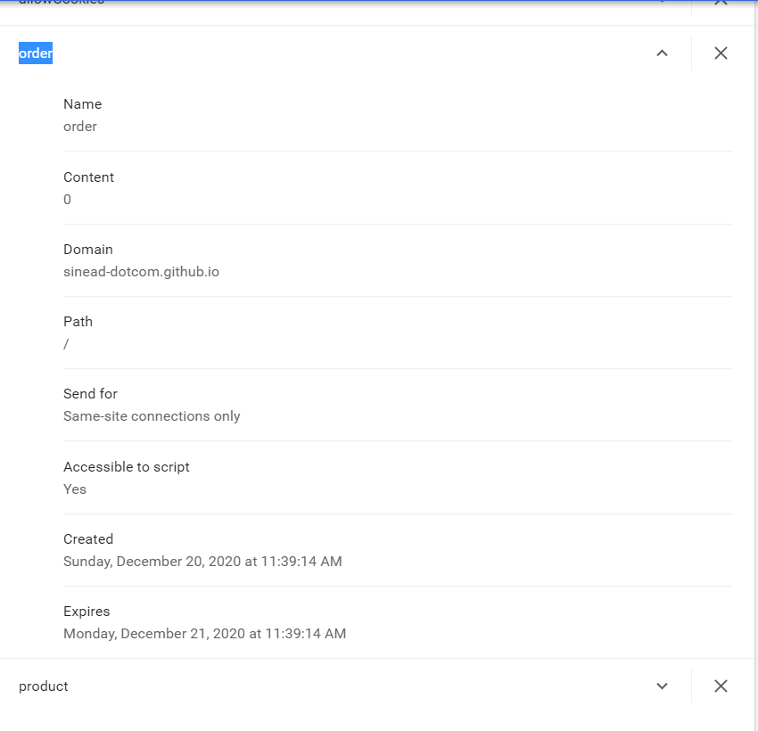

So, next test was to delete the cached cookies from the browser. Then reload the page and see what happens. The user was prompted to consent to cookies again – using the lovely bootstrap modal.

## Automated Testing

## HTML/CSS/Java testing

## Cross platform testing

## Validation testing

Form testing for the subscription page.

It was interesting to see that the autofill function was working.

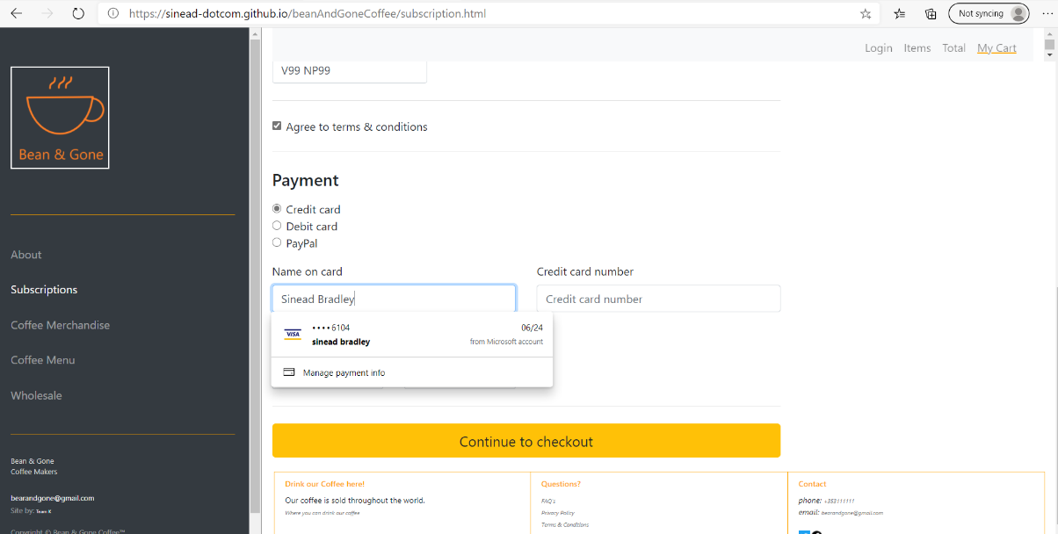

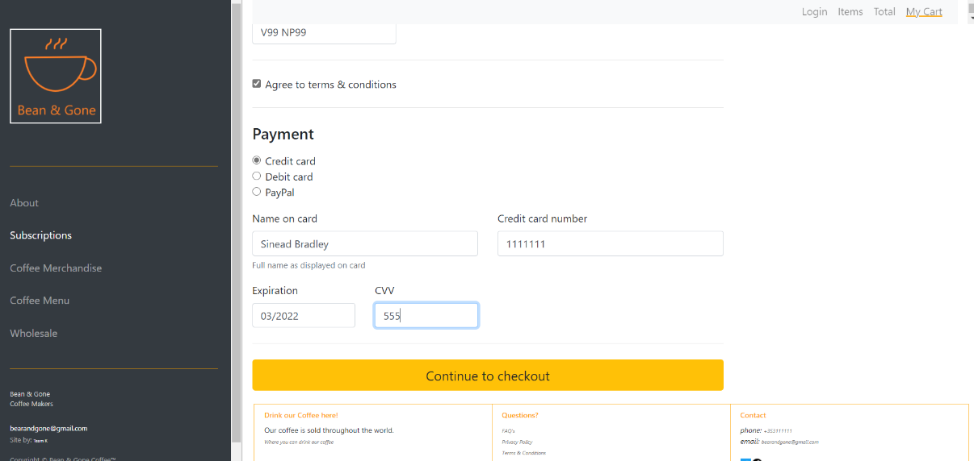

The error checking and validating worked on the subscriber page.

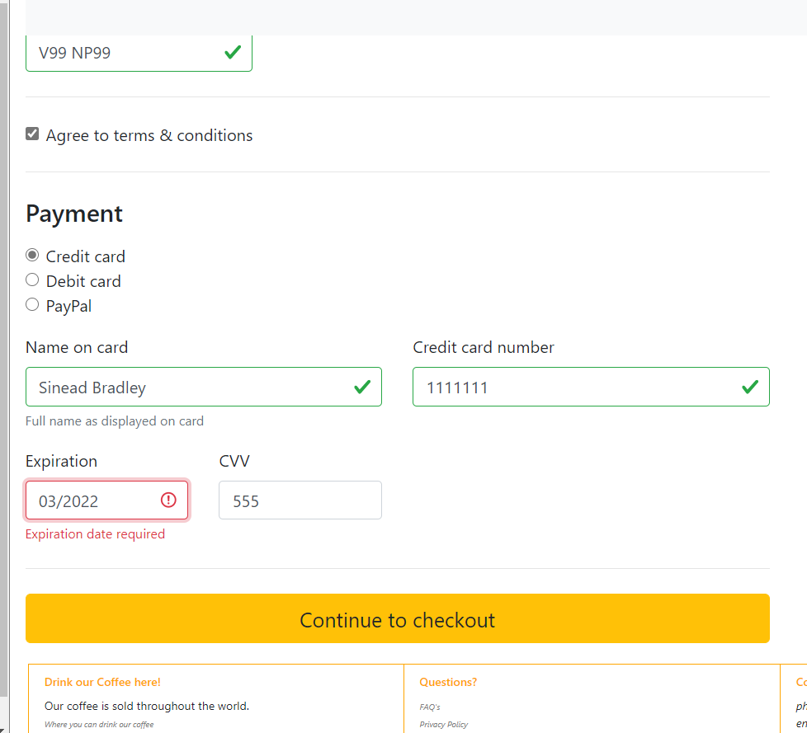

And once all fields were valid, and I clicked “Continue to checkout”, an email was launched to show the action.

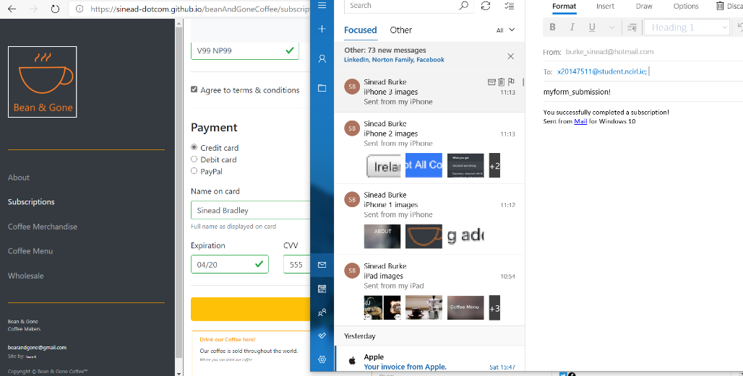

During the testing I noticed that the firstname field did not have a placeholder value:

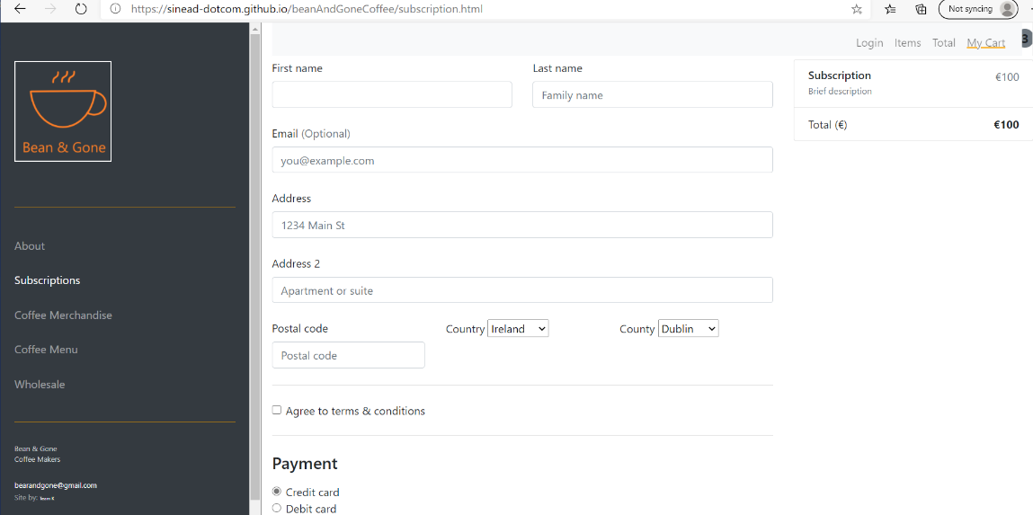

It was lovely to see how the autofill worked:

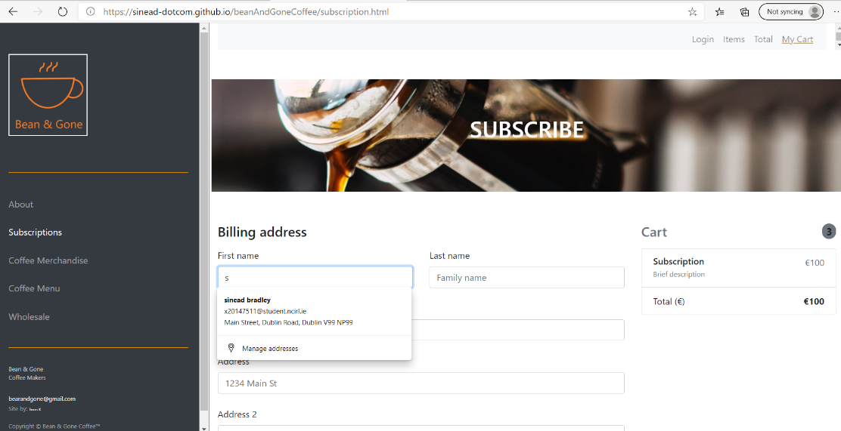

And the form made the user complete all fields before it would proceed:

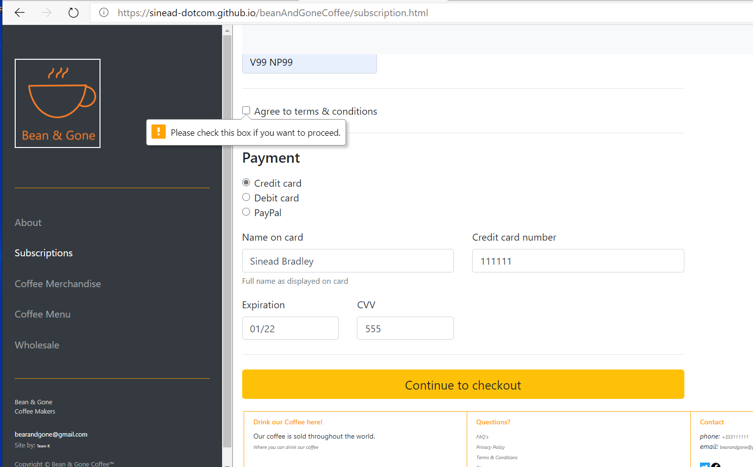

## Responsive design testing

## Advanced testing tools